# Quiz # 1 Web Programming - Section (B)

**Total Marks: 10 Time: 60 minutes**

1. What is the difference between manage code and unmanaged code? **(1 marks)**
2. Write a Program that take command line arguments of first name, last name, age, gpa and Cgpa, concatenate name and last name and display name, age, gpa and Cgpa on console**. (2 marks)**
3. **Code the following: (7 marks)**

Henry is your project manager. Currently he is working on a mobile services management system. Right now, he is implementing CMS (Customer management module). Rough Database structure is as follows

Customer (id, Username, password, FullName, Location, AccountType)

Where id and username are unique.

Account Type are:

1. Administrator

2.Customer

He has hired you as a fresh software engineer, he wants you to implement the customer management module using **3 tier architecture**.

Henry plans to work with database so he has instructed you to use Data base system this means you have to make table of customer in database. Schema is like

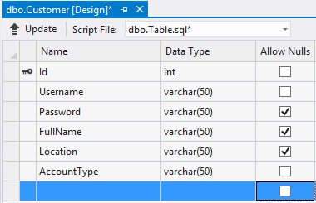

**Note:** Parameterized queries should be used in program

**Task (Administrator functions)**

Admin should have an admin panel through which he/she can

* insert customer
* update customer
* delete customer
* search customer
* display all customer

**Task (Customer functions)**

Customer can

* login
* logout
* change password